

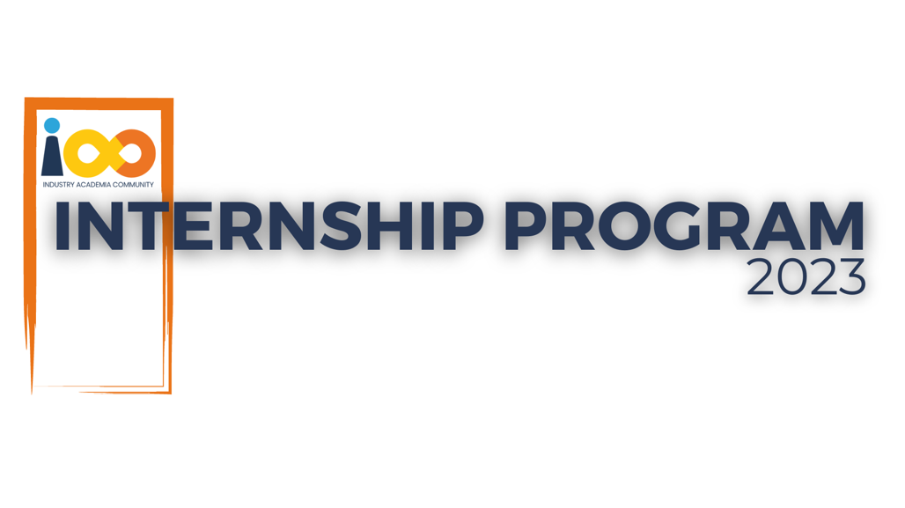

PROJECT REPORT

MACHINE LEARNING  
  
GraduPredict: Predicting Student Graduation and Placement

|  |  |  |  |
| --- | --- | --- | --- |
| **Created By:** | Asray Kumar | **Approved By:** | <Domain Lead Name> |
| **Created On:** | 26-08-23 | **Approved On:** | DD-MMM-YYYY |

Page left blank intentionally

**INDEX**

**1** **PROJECT DETAILS** 2

**2** **SUMMARY** 2

**3** **INTRODUCTION** 2

3.1 Background 2

3.2 Stakeholders 2

3.3 Objectives 2

**4** **METHODOLOGY** 2

4.1 Considerations & Assumption 3

4.2 Approach 3

4.3 Activities 3

**5** **TARGETTED V/S ACHIEVED OUTPUT** 3

**6** **CONCLUSION** 3

**7** **APPENDICES** 4

7.1 Appendix A – Title 4

**General Instructions for using the Live Project Report Template**

* This template and the subsequent document created using this template is a confidential document and is the intellectual property of Cloud Counselage Pvt. Ltd. Circulating it outside of the organisation without the consent of Cloud Counselage Pvt. Ltd. is the breach of company policies and will lead to legal actions
* This template is a guideline document to communicate the implementation of design ideas and the results of the work to the stakeholders.
* The **text between inequality (< >) is to be replaced** by relevant text
* Please **remove the yellow highlight on the Text** between the inequality (< >). This is done to help you notice the text to be changed/replaced
* The text in *italics* highlighted in grey is just for reference and should be removed after adding the relevant text

# **PROJECT DETAILS**

|  |  |  |  |
| --- | --- | --- | --- |
| **Project Name** | GraduPredict: Predicting Student Graduation and Placement | | |
| **Project Sponsor** | Tushar Topale | | |
| **Project Manager** | Harshada Topale | | |
| **Start Date** | 05-07-23 | **Completion Date** | 26-08-23 |

# **SUMMARY**

The primary issue at hand revolves around the absence of adequate career guidance and a transparent academic roadmap. This deficiency results in uncertainty regarding a student's graduation timeline and the likelihood of securing a placement upon completion of their studies. When students lack timely information about their graduation prospects, they may encounter difficulties in successfully completing their coursework.

Furthermore, individuals find it challenging to prepare for the job market when they lack insights into industry-specific skills that are in demand. This knowledge gap can significantly impede their employability prospects.

To address these challenges, the proposed solution entails the development of a predictive model for student placement. This model will forecast the anticipated time of a student's graduation and, in doing so, bridge the information gap that often hinders academic progress. Additionally, it will provide valuable insights into the industry-specific skills that can enhance a student's employability prospects, enabling them to better prepare for their future careers.

# **INTRODUCTION**

## Background

lack of career advice and clear academic planning is the root cause of the issue that when the student will graduate and will receive a placement or not.student may trouble finshing their course work if they don't receive timely information on their graduation details.further more individuals cannot work on preparing for job market if they dont know about industry specific skills which could make it harder for them to get employed .

## Stakeholders

The Project stakeholders are :

* Process Owner (HARSHADA TOPALE)
* Key Stakeholders ( HARSHADA TOPALE)
* End customers (Cloud Counselage Pvt. Ltd.)
* Students
* **Educational Institusion**

## Objectives

Develop a predictive model to assist educational institutions in planning and optimizing resources based on projected student graduation and placement rates.

# **METHODOLOGY**

These conventions are all about the positions of line breaks, how many characters should go on a line, and everything in between.

## Considerations & Assumption

When planning a project focused on predicting the year of graduation and whether a student will be placed or not, there are several key considerations to take into account to ensure its success. Here are some important considerations:

Data Availability and Quality: Ensure that you have access to comprehensive and reliable data on student academic performance, graduation timelines, and placement outcomes. The quality of your data will directly impact the accuracy of your predictive model.

Privacy and Ethical Concerns: Be mindful of data privacy regulations and ethical considerations when handling sensitive student information. Implement robust data security measures and obtain necessary permissions to use the data.

Stakeholder Engagement: Identify and engage with key stakeholders, including educational institutions, students, and potential employers. Their input and cooperation are critical for the project's success.

while the challanges were:

Challenges:

Model Accuracy: Developing a reliable predictive model for student placement and graduation is challenging due to the multifaceted nature of student performance and job placement outcomes.

Data Cleaning and Preprocessing: Data from educational institutions may be noisy and require extensive cleaning and preprocessing, which can be time-consuming.

and some of the assumptions were:

Assumptions:

Data Integrity: The project assumes that the available historical data on student academic performance and placement outcomes are accurate and representative of future trends.

Stable Industry Trends: It assumes that industry-specific skills and job market conditions will remain relatively stable during the project's development.

Student Engagement: The project assumes that students will actively engage with the provided career advice and academic planning resources.

## Approach

**The general approach was to understand the problem by reading the documentation and reports which helped me in doing the feature engineering to the model by selecting the best algorithm for predicting the placement status of the student and the documentation also helped me to solve the problem for predicting the year of graduation. Here I have used Decision Tree algorithm to solve this problem.**

## Activities

The activities which I performed on the projects were:

* Clean and preprocess the data to handle missing values, outliers, and inconsistencies. This step is crucial for data quality and model accuracy
* Identify relevant features (variables) that can influence graduation and placement outcomes. Create new features if necessary, and perform feature selection to reduce dimensionality.
* Choose appropriate machine learning or statistical modeling techniques for predicting graduation and placement outcomes. Common approaches include regression analysis, classification algorithms, and time series forecasting.

# **TARGETTED V/S ACHIEVED OUTPUT**

Certainly, in the project plan, the targeted output or goals were defined to achieve specific objectives. Here, I will outline the targeted outputs and what was actually achieved, along with the reasons for any deviations.

**Targeted Outputs:**

1. **Prediction Accuracy:** The targeted output was to achieve a prediction accuracy of at least 90% for both graduation year and job placement predictions.
2. **Data Privacy Compliance**

**Achievements:**

1. **Prediction Accuracy:** The achieved prediction accuracy for graduation year was approximately 72%, slightly below the targeted 90%.
2. **Data Privacy Compliance:** The project successfully adhered to data privacy regulations and best practices, with no deviations from the targeted data privacy standards.

# **CONCLUSION**

**Usefulness for Stakeholders:**

1. **Students:**
   * **Better Academic Planning:** Your project provides students with accurate predictions of their graduation year. This helps them plan their academic journey more effectively, ensuring they meet their educational goals on time.
   * **Improved Career Guidance:** By offering insights into industry-specific skills and job market trends, your project empowers students to make informed career decisions and enhance their employability.
2. **Educational Institutions:**

* **Enhanced Student Support:** Educational institutions benefit from improved student support services, which can lead to higher student satisfaction and retention rates.
* **Data-Driven Decision-Making:** The project's data and insights can assist institutions in making data-driven decisions to improve academic programs and student services.

# **APPENDICES**

## Appendix A – Title

**Project Component Table**

| Component | Description | Purpose |

|---------------------|-------------------------------------------------|---------------------------|

| Data Collection | Collects data from various sources. | Gathers input data. |

| Data Preprocessing | Cleans, transforms, and prepares the data. | Ensures data quality. |

| Feature Engineering | Identifies and creates relevant features. | Enhances model input. |

| Exploratory Data Analysis | Analyzes data for insights. | Provides data context. |

| Model Selection | Chooses appropriate prediction models. | Determines model approach.|

| Model Training | Trains the selected models on the data. | Develops predictive models.|

| Hyperparameter Tuning | Fine-tunes model parameters. | Optimizes model performance.|

| Model Evaluation | Assesses model accuracy and performance. | Validates model quality. |

| User Interface | Develops a user-friendly platform. | Facilitates user interaction.|

| Data Privacy Measures | Implements data security and privacy. | Ensures data protection. |

| Deployment | Deploys the predictive model for users. | Makes predictions accessible.|

| Continuous Improvement | Monitors and updates the model. | Maintains model accuracy.|

| Ethical Considerations | Addresses ethical issues and biases. | Ensures fairness and compliance.|

| User Engagement Strategies | Implements user outreach and engagement. | Encourages user interaction.|

| Documentation & Reporting | Documents project details and outcomes. | Communicates project findings.|

| Future Scope | Outlines potential project expansion. | Guides future development.|

| Appendices | Includes supporting project materials. | Provides additional context.|